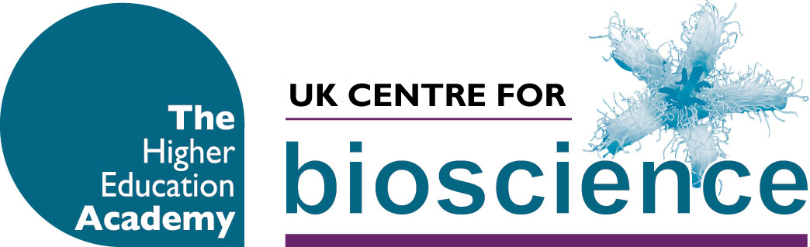
Travel bursaries
Final Year Projects :Maximising the Learning 13th May 2010
Travel bursaries are aimed at bioscience teaching or support staff without access to travel/development funds to enable them to engage with Centre events and share and learn from effective practice elsewhere.
The funding will be available to help colleagues attend UK Centre for Bioscience Professional Development Events and Regional Forums. The maximum value of each bursary will be £150 and there will be up to two bursaries available per event. The funding is for travel costs only, not for food or accommodation and is available to colleagues working at UK institutions only.
Colleagues are invited to submit an application using the proforma provided. Please note that successful recipients of the bursaries will be asked to write a report on the event for the Centre in addition to presenting their reflections at the end of the event.
Please note that all applications must be approved by your Head of Department (or equivalent).
Applications can be made for more than one event but preference will be given to those who have not previously received an award. Applications cannot be made retrospectively. Applications will be reviewed a month prior to the event and applicants informed promptly of the decision. Successful applicants will be issued with an expenses form and reimbursed for receipted expenditure after the event.
Name:
Job Title:
Department/School:
Institution:
Address:
Telephone: | Email address:
Brief description of how you expect this event to influence your teaching/support of teaching (150 words).

Signature: | Date:
Signature of head of department/School (if applying electronically please ask them to send an email to heabioscience@leeds.ac.uk confirming their approval). | Date:

Please return this form to: UK Centre for Bioscience, The Higher Education Academy, Room 9.15, Worsley Building, University of Leeds, Leeds, LS2 9JT Or email heabioscience@leeds.ac.uk

